**\*\*Sonar Cloud User Guide\*\***

----------------------------------------------------------------------

**Install Sonar Cloud:**

1. Navigate to <https://sonarcloud.io/>

2. Click on "GitHub" in "Analyze your repo" and Sign in

3. Click through and create organization if needed

4. Click Analyze new Project & Select Repository you want to Analyze

5. Select "Manually" under Analysis Method

6. Choose the programming language under what option best describes your build. (Support Languages: <https://sonarcloud.io/documentation/advanced-setup/languages/overview/>)

7. Choose your OS & Download the Files

**Windows:**

8. Follow instructions to add bin directory to the path environment variable(Refer: <https://stackoverflow.com/questions/44272416/how-to-add-a-folder-to-path-environment-variable-in-windows-10-with-screensho>)

9. Download or create "sonar-project.properties" file in the root folder of your repo (Refer: <https://sonarcloud.io/documentation/advanced-setup/ci-based-analysis/sonarscanner/>)

Example of a property file for java:

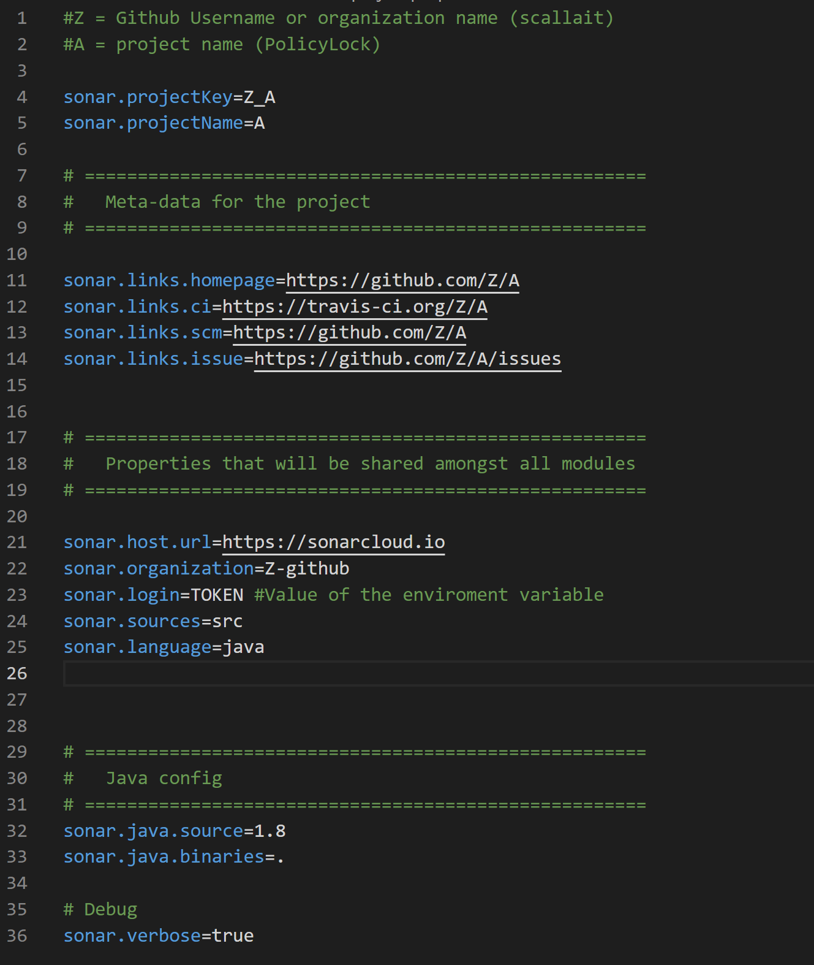

**\*\*Note – the environment variable should be provided by sonarcloud**

10. Open Gitbash

11. Execute the command of this form given from sonar cloud in git bash or terminal in the project folder to run analysis:

**\*\*Note that your organization and projectKey will be different**

**Run Sonar Cloud Analysis:**

1. Navigate to folder containing repository and project

2. Run Command:

- sonar-scanner.bat -D"sonar.organization=user" -D"sonar.projectKey=user_repoName" -D"sonar.sources=." -D"sonar.host.url=https://sonarcloud.io"

3. Example: user= scallait, repoName = PolicyEnforcement

- sonar-scanner.bat -D"sonar.organization=**scallait**" -D"sonar.projectKey=**scallait_PolicyEnforcement**" -D"sonar.sources=." -D"sonar.host.url=https://sonarcloud.io"